**SOLENT UNIVERSITY**   
School of Media Arts and Technology

BSc (Hons) Software Engineering

Academic Year 2019-2020

Mohammed Buhari Fathima Shenaz

Project CDA600

Wearable emotion controller device using IoT **Review Report AE1**

Contents

1. Introduction 2

**2.** Methodology 3

a. Evaluation of the Solution 4

a. Block Diagram 8

b. Overview Diagram 9

c. IOT Model 9

d. Proposed Artefact 10

3. Design, implementation 11

4. Project Progress 11

a. Legal issues & Ethical issues 11

b. Project plan 12

5. Project Management 13

6. Further Development 13

7. Conclusions 13

8. Reference List 14

9. Bibliography List 14

Table of Figures

Figure 1 mood disorders 5

Figure 2 Neurotic stress disorders 6

Figure 3 mental retardational disorders 6

Figure 4 Question 1 7

Figure 5 Question 2 7

Figure 6 Question 3 8

Figure 7 Question 4 8

Figure 8 Question 5 9

Figure 9 Question 6 9

Figure 10 Block diagram 10

Figure 11 Overview diagram 11

Figure 12 IOT model 11

Figure 13 phase 1 14

Figure 14 phase 3 14

Figure 15 phase 2 14

# Introduction

There is an inattention problem that every human being is facing which they do not concentrate much but it may lead to huge disasters. That means critical emotional ranges of humans.

*Based on research by the Institute of Neuroscience and psychology at the University of Glasgow, considered There are Four basic emotions which everyone is facing. Such as Happiness, Sadness, Fear/Surprise, and Anger/Disgust*. (Our Basic Emotions Infographic | List of Human Emotions | UWA Online, 2020)

Hiddenly They are ruled by those kinds of emotions which mean, activities they have done, decisions /suggestions they agreed likewise, they all influenced by those emotions which they experiencing at all certain moments.

According to the research, Anger is a such a strong emotion which is affected others emotionally also harmfully and it may lead to hypertension. Humans are don’t concentrate on Anger but it will cause insomnia, digestion problem, skin problems, headache, heart attacks, and stroke.

And also, Sadness may lead to depression. In Healthline web page, [Timothy J Legg,](https://www.healthline.com/medical-team) Medically reviewed There are some risk factors in depression such as,” *trouble adjusting to a medical condition, such as cancer, stroke, chronic pain, or heart disease, trouble adjusting to body changes due to catastrophic injury, such as loss of limbs, or paralysis, history of prior mental health disorders, including anorexia, bulimia, post-traumatic stress disorder (PTSD), or anxiety disorder and also it may lead to Think about suicide.”* (Whelan, 2020)

Next the Fear means a helpless moment that they have to face. [Dr. Ekman's Blog](https://www.paulekman.com/blog/) reviewed as “*The universal trigger for fear is the threat of harm, real or imagined. While there are certain things that trigger fear in most of us, we can learn to become afraid of nearly anything.”* (What is Fear? | What Causes Fear? | Paul Ekman Group, 2020)

It may lead to, “*feel excessively sad or low, Extreme mood changes, including uncontrollable “highs” or feelings of euphoria, Overuse of substances like alcohol or drugs, Multiple physical ailments without obvious causes (such as headaches, stomach aches, vague and ongoing “aches and pains”) and also thinking about suicide.“* (Know the Warning Signs | NAMI: National Alliance on Mental Illness, 2020)

Therefore, recommending an Emotion controller device will help to avoid such risky states. And also, it will enhance the society's well-being.

# Methodology

I used so much of literature sources for research about the emotions, impact of anger and fear, how to control them as well as what the method s to follow, what the components help to reduce those emotion ranges and so on. Inside the project proposal I summarized every information which I learned and gathered in understandable manner.

I carry out the project with experimental research methodology because there is an artifact which is planning to implement. Experimental methodology using for generating a new solution to the problem. According to the project there are so much of questions. Such as, How is going to detect the emotion range, how is the data collected or generated, Is it possible to implement, how it is going to work, how was it analyzed, what are the components, and etc.

If the system data were detected through the sensors, it would communicate through the microcontroller and it was passing the data to Blynk visualization app over the Wi-Fi. That's how the analysis happens. There is no sensitive data used for this project and used only collected data which is gathered for testing purposes.

Project artifacts will give the exact solution to these questions and in the artifact phase it will explain what the system is supposed to do.

In below I evaluated my solution to justified that my system which I planning to do will help to the people live peacefully and mitigate the upcoming mood issues in the future.

## Evaluation of the Solution

According to the data from the Department of Census and statistics of Srilanka, there are a huge number of people who had Mood disorders. Which means, most people are struggling to control their moods.

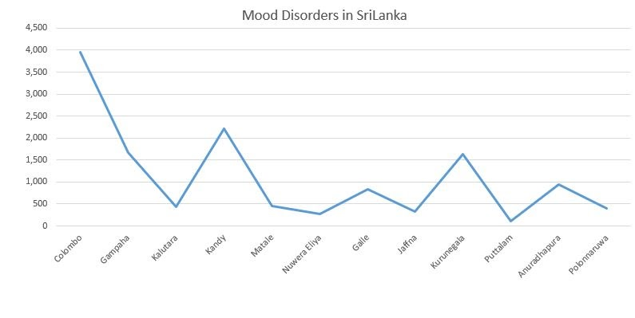

Figure mood disorders

In the below screenshot will represent the neurotic, stress related disorders. It may cause anger, anxiety, over-thinking, sadness and also fear.

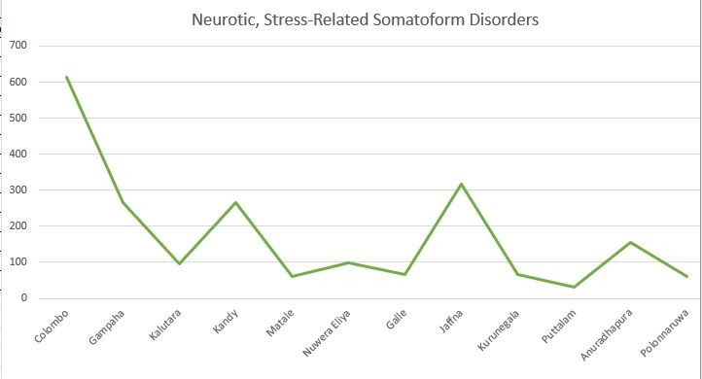

Figure Neurotic stress disorders

And also, their mental health was weak. That's what they have Mental retardation related disorders. That will represent in below screenshot. Most of people don't care about their mental health. Now itself people have to be aware of these kinds of issues and they have to take proper treatments.

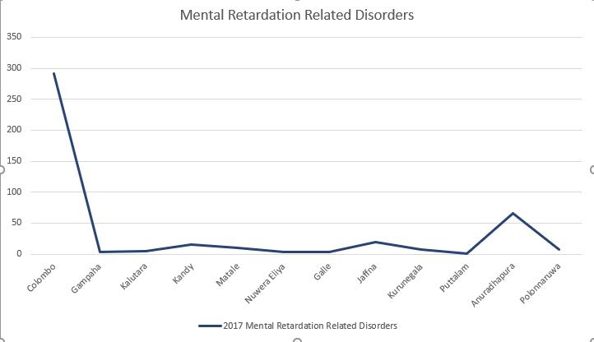

Figure mental retardational disorders

According to my research, I gathered some information among the questionnaires which consisting of a series of questions for the purpose of gathering information from respondents. It is effective because of measuring the behavior, attitudes, preferences, opinions and, intentions of relatively large numbers of subjects more cheaply and quickly than other methods. This means questionnaires are one of the most affordable ways to gather quantitative data.

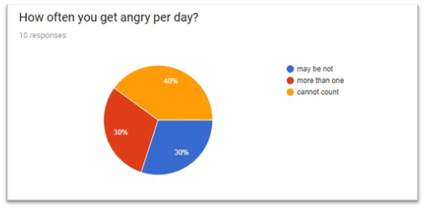According to my first question, most of the people get angry per day.

Figure Question 1

 And also my second question result is , most people are walking away when they get angry, some people are standing up for themselves, and fight back.it is not healthy habit at all. It makes your angry level more and higher. Because of that you may be lost your mind’s calmness. After that, they may have some disturbed conscious

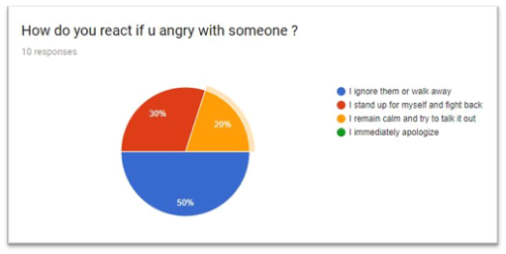

Figure Question 2

According to my next question Majority of people are get from that place when they get angry and 40% of people are tend to shout in that situation. That emotion is so dangerous. Chronic anger can increase your heart attack and stroke risk. It can also weaken your immune system. In fact, anger may help some people think more rationally.

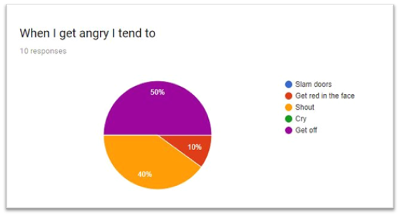

Figure Question 3

According to my next question, an equal percentage of people destroyed something when they get temper.  It has called a redirected attack. When we get angry with another person, we have the need to attack him or her in some way. However, for a variety of reasons (including that, attacks are energetically costly and that actual attacks can shatter social bonds) it is actually more adaptive to redirect the attack at some other object. Therefore, if I get furious at you, I will most likely slam my hand on the table or smash something instead of punching you in the mouth and smashing your mind.

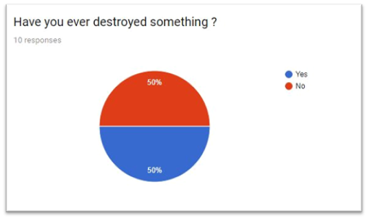

Figure Question 4

According to my next question, the majority of people are not exactly regret what they destroyed during the argument.

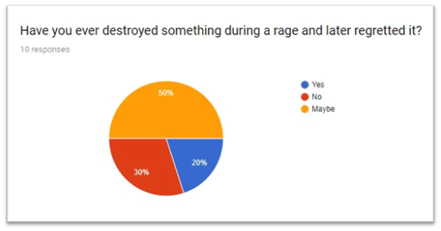

Figure Question 5

According to my last question, people agree with anger is not healthy habit.

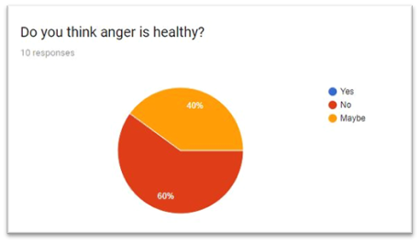

Figure Question 6

## Block Diagram

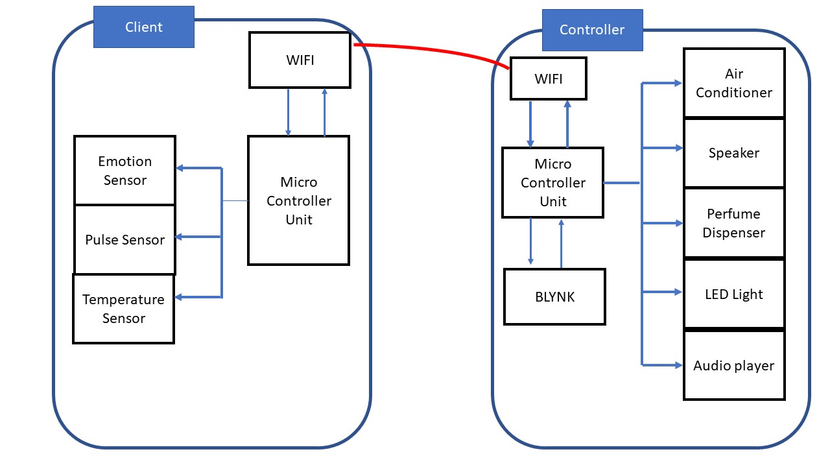

Figure Block diagram

## Overview Diagram

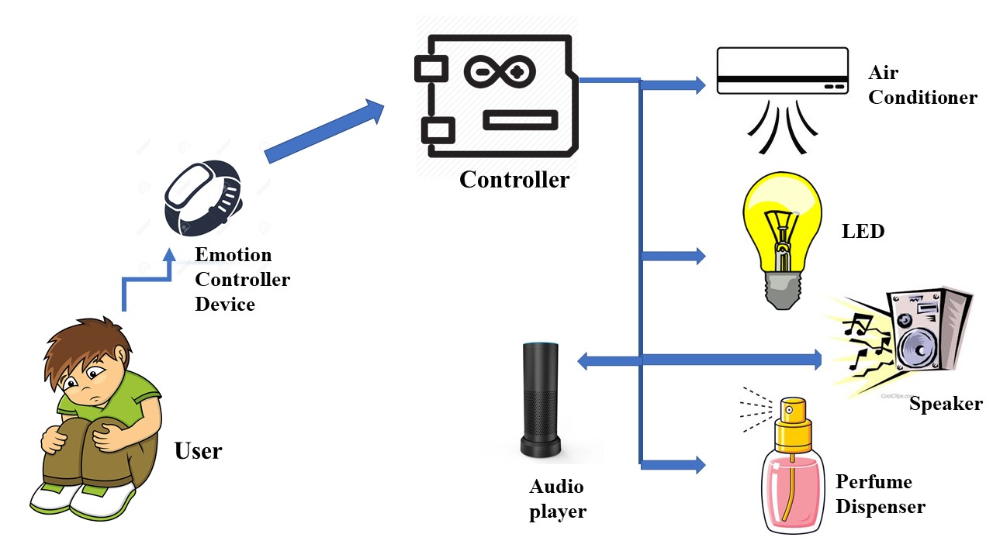

Figure Overview diagram

## IOT Model

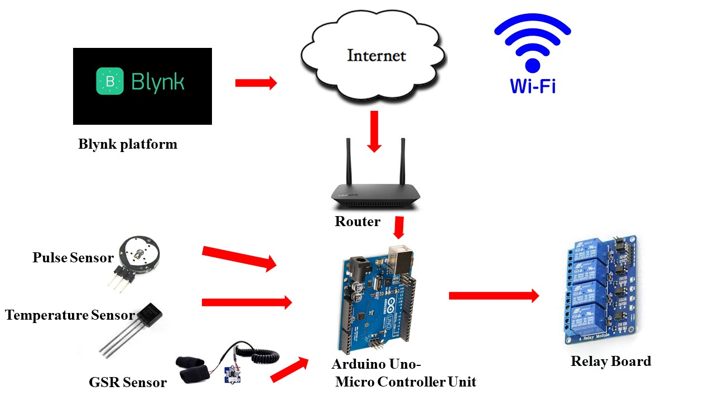

Figure IOT model

## Proposed Artefact

This project supposed to do a wearable device that is made for the home environment. It will calculate the pulse of the user through the sensor, and it will calculate the range of the user’s emotion which means the device detects pulse and identifies the range of emotions and communicates with controller and it works how the system was commanded.

If the user is in Anger, it will change the light into warm because flashlights may increase the anger level and also, switch on the Air conditioner, playing warm music, and also controller will on the perfume dispenser. Finally, there is an audio player it will give the advice to the user which he needs to control the anger.

*According to the research bright light will helps us to feel more energized, decisive*.

(architecture, 2017)

As well as, Perfumes contain neurotoxins, which have a causal link to central nervous system disorders, headaches, confusion, dizziness, short-term memory loss, anxiety, depression, disorientation, and mood swings. Finally, temperature also matter for the anger and anxiety. Therefore, I command to on the air conditioner automatically.

If the user is sad, All the components work according to the command which is related to the sad state. And also, that audio player will give the advice to change the mind-set and also it will say several motivational facts to avoid the mood. People are commonly had a problem is They do not have a person to advice or talk in their sad mood. Then the system will help to give advices to avoid their condition.

Finally, for the Fear state also the system will work relate to the fear state and audio player will help to overcome the situation.

This system will help to avoid these kinds of Critical issues and also enhance society’s wellbeing. I hope the progress will help to enhance the unhealthy range of emotions.

# Design, implementation

Emotion controller device is fully automated and the device is made for the home environment. I used a micro controller board to system because it has good efficiency, accessibility of WIFI, loading speed and also the capability of pin count. System data was controlling, analyzing, capturing, monitoring by the Blynk Platform. It helps to enhance the system's effectiveness.

# Project Progress

In my project, I used blynk platform to visualize and analyze the activities of the system which I explained about. That will help to detect whether the data are working correctly or not. And also, the entire system was connected with the blynk platform over the same connection. The project is made for any kind of a human being. There are no restrictions. System will help to identify the emotion range among the GSR and Pulse sensor. Then the device will help to Avoid the hyper emotions as soon as possible.

## Legal issues & Ethical issues

* In this system there is no any harm to any human being.
* Carefully I carried out the project.
* This system is especially made for enhancing society wellness.
* I follow some guidelines to protect my data from threats.
* Main rule of the project is I don't take any real sensitive data to test the project.

## Project plan

Figure 13 phase 1

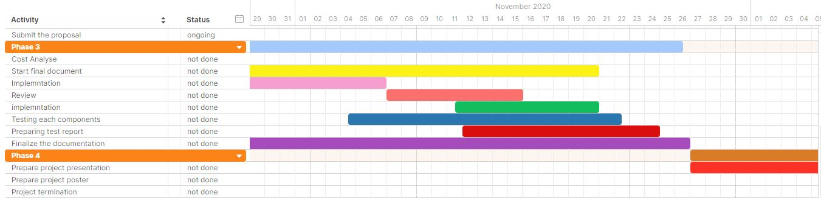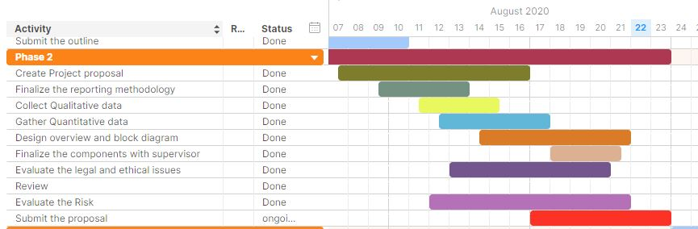

Figure 14 phase 3

Figure 15 phase 2

# Project Management

Time management – There is only 400 hours for total work which is given by solent. First a fall I break down the workload according to the time schedule. It enhanced the project in a better way and it is the reason for effectiveness of my project. I took more time to collect qualitative data but also took less time to Choose the reporting methodology. I divided the workload among the importance of each stage.

Risk management- The project is based on IOT But I don’t have an much knowledge about iot Components that was the main risk which I was faced. Therefore, I went through more research and I followed many tutorials to overcome that risk. the next one is the cost. Real cost is higher than pre-planned cost. While implementing the stage by mistakenly one of the circuits will burn, I have a capability to replace with another because I have only a limited time schedule. Then That was my contingency plan. If there is any uncertain thing happening to my components, I can tolerate that issue. I am capable of mitigating such issues.

# Further Development

I made my emotional controller device to the home environment. It is based on a particular room. I need to make my system into an entire home in the future development. Because it is based on home environment and also, I plan to work the system without Wi-Fi connection. Along that user can feel relaxed and comfortable.

# Conclusions

This project is an innovative system to the industry. None of people have started a system like this before and also This is a creative model for controlling the states of emotions. This is an inattention problem that everyone must skip but also it may lead to a huge disaster. This system will help to avoid the negative emotions and also it makes a comfortableness to the user. This system is made to enhance the society's well-being and cooldown the mental level of the humans. It may help people to feel free and fresh.

# Reference List

Nami.org. 2020. *Know The Warning Signs | NAMI: National Alliance On Mental Illness*. [online] Available at: <https://www.nami.org/About-Mental-Illness/Warning-Signs-and-Symptoms> [Accessed 20 August 2020].

Paul Ekman Group. 2020. *What Is Fear? | What Causes Fear? | Paul Ekman Group*. [online] Available at: <https://www.paulekman.com/universal-emotions/what-is-fear/> [Accessed 20 August 2020].

UWA Online. 2020. *Our Basic Emotions Infographic | List Of Human Emotions | UWA Online*. [online] Available at: <https://online.uwa.edu/infographics/basic-emotions/> [Accessed 20 August 2020].

Whelan, C., 2020. *Depression Vs. Sadness: What’S The Difference?*. [online] Healthline. Available at: <https://www.healthline.com/health/depression/depression-vs-sadness> [Accessed 20 August 2020].

# Bibliography List

aplanforliving, 2019*. 6 WEARABLES TO TRACK YOUR EMOTIONS.* [Online]   
Available at: http://www.aplanforliving.com/6-wearables-to-track-your-emotions/

Arthur, A., 2014*. Feeling mad? New devices can sense your mood and tell — or even text — others*.. 13 01.

Chopra, D., 2020. *How To Manage Your Anger.* [online] Chopra. Available at: <https://chopra.com/articles/how-to-manage-your-anger> [Accessed 7 August 2020].

Elizabeth Scott, M., 2020. *How to Manage Anger and Stress*. [Online]   
Available at: https://www.verywellmind.com/the-effects-of-anger-and-stress-3145076  
[Accessed 31 01 2020].

Le, T., 2012*. How Mind-Controlled Devices Will Change Our Future.* 18 09.

Mahto, J., 2015. *Why We Need IoT (Internet of Things). Linkedin, 18 11, pp.* <https://www.linkedin.com/pulse/why-we-need-iot-internet-things-jugeshwar-mahto>

# Appendices